CMP 543 Intro to Systems: Designing for Interactivity

Professor Lien Tran

Fall 2014

**Final Project: “The Daily Grind” Depression Awareness Game**

**Kelsey Kjeldsen**

1. **Abstract**

Depression is a very common illness, but has been given a negative stigma for a long time in American society. Almost 20% of the public considers depression a sign of personal weakness and 23% would be embarrassed to tell others if a family member were diagnosed with depression. [[1]](#footnote-1) This stigma has made it especially difficult for young adults to speak openly about depression. Organizations like NAMI, NIMH, and Bring Change to Mind have paved the way to educate the public and young people about depression in hopes of reducing stigma and increasing mental health awareness. At least 350 million people live with depression, and it is the leading cause of disability worldwide. In addition, 50% of those sufferers do not seek medical help.[[2]](#footnote-2) Unfortunately, I have had friends lose their lives because of mental illness and suicide so I hope that “The Daily Grind” game help prevent these tragedies in the future.

The Daily Grind is an interactive game for high school classes that allows students to learn symptoms of depression by simulating the effects depression has on a person’s daily life. The Daily Grind educates players about the symptoms people with depression experience and possible treatments. The goal of Daily Grind is to create a meaningful game used as a classroom exercise that will help reduce stigma about depression.

1. **Motivation**

Unfortunately, I have had friends lose their lives because of mental illness and suicide and I do not want anyone else to suffer in the same way so I hope this game can have a positive impact. A few years ago a friend of my brothers, [Alexis Pilkington,](http://www.giveeverythingbutup.com/" \t "_blank) took her life at just 17 years old and her family has now dedicated themselves to suicide awareness and prevention. A few years later another friend, and alumna of my high school, took her own life after a long battle with depression. These events prompted me to further research the topic and I discovered how widespread depression can be and that there is still a large amount of stigma surround the topic. I knew there needed to something done about it. I hope that by creating this game and mentioning her story that people can realize the impact of mental health and join in helping spread awareness.

1. **Design Questions**
2. How will players “feel” the effects of symptoms of depression?
3. How can I represent the randomness of symptoms, and the effects they have on decision-making?
4. How can I simulate day-to-day tasks, but still have a fun game?
5. How can I increase the amount of choice and interaction within the game?
6. How do I provide meaningful facts and research without boring high school students?
7. **Concept Statement**

About 34% of people living with depression report first feeling symptoms before age 18, but there are many factors that keep those people from seeking help.[[3]](#footnote-3) It is important for young adults to learn about depression, ways to help those with depression, and how to seek help without the feeling embarrassed or uncomfortable. A solution to this problem is an interactive game called The Daily Grind, which allows students to learn about the symptoms of depression and the various treatment options that are available.

1. **Audience**

Daily Grind is meant to be used in a high school classroom with students’ ages 13-18 years old. The game is meant to facilitate conversion about a relatively uncomfortable topic in a more lighthearted, interactive way. The game will allow students to learn about depression symptoms and treatments while still getting to play a “fun game.” Since about 11% of teenagers 18 years and under have a depressive disorder, this game is a way to hopefully reduce stigma of their disorder and give them the confidence to speak out about it.[[4]](#footnote-4)

1. [**User Scenario**](http://kelseykjeldsen.com/daily-grind-promo-video/)

A health teacher is looking for a new way to inform students about mental health in a less “grim” way. She researches new lecture materials and comes across this interactive board game about depression awareness, called The Daily Grind. She decides to incorporate it into her class activities. She briefs the students quickly about what they will be playing and how the game works. She asks them to tell her some thoughts that come to mind for them when they think about mental illness and write them down without sharing. The students save their responses then start to play the game.

She allows the students to play through the game and talk about their experiences as the games go on. After the students have finished completing the board game the teacher ask the students to again write down their thoughts about mental illness. She then asks them to compare their responses. This facilitates better conversation for the students and teacher about the signs, symptoms, and treatments for mental illness and hopefully reduces the stigma that young adults have about mental illness.

1. **Domains**

There are many research areas that involve mental illness, and specifically depression. For The Daily Grind, the focus was on depression symptoms, causes, treatment, and services research. There are lots of organizations that dedicate their time to improving education and research about depression and mental illness, but this project focused on only a few. The game uses research provided by:

* National Institute of Mental Health ([NIMH](http://www.nimh.nih.gov/health/publications/depression/index.shtml))
* National Alliance of Mental Health ([NAMI](http://www.nami.org/))
* World Heath Organization ([WHO](http://www.who.int/mental_health/management/depression/flyer_depression_2012.pdf?ua=1))
* [Bring Change to Mind](http://bringchange2mind.org/learn/what-is-stigma/).

Most organizations focus their research on symptoms and treatments for depression, but Bring Change to Mind had a specific focus on the stigma of mental illness, which helped tremendously in creating game cards for The Daily Grind. They provide stories from people who experienced depression and give first hand accounts of how they were/are affected. These stories and research about stigma helped to create copy text that was relatable and allowed players of the game to put themselves in the shoes of those who are suffering from depression.

1. **Precedents**

There are not many “games” in existence that tackle the challenges of educating about or reducing the stigma of depression, but there are a few projects that are similar. Each of the projects below had an influence on the game design process of The Daily Grind:

* [Depression Quest](http://depressionquest.com/)

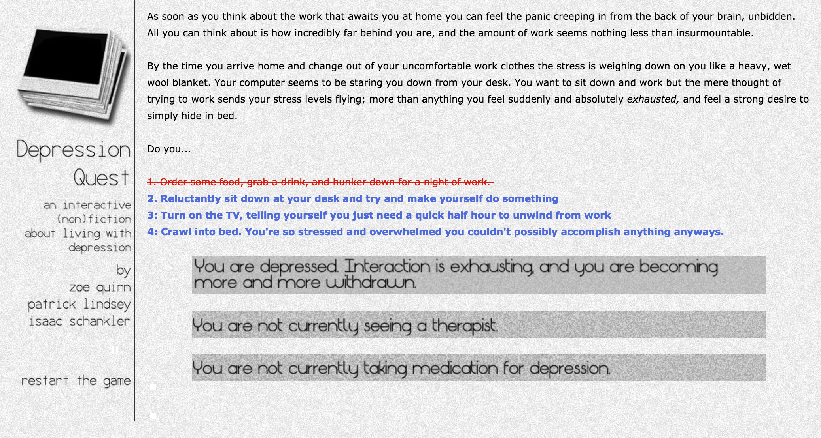

* [We’ve Got Issues](http://issuesthegame.com/)

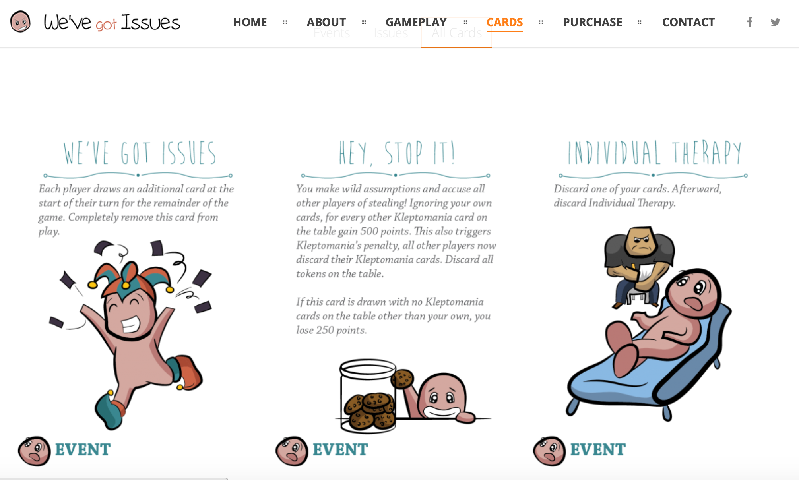

* [Cops and Rubbers](https://www.thegamecrafter.com/games/cops-rubbers)

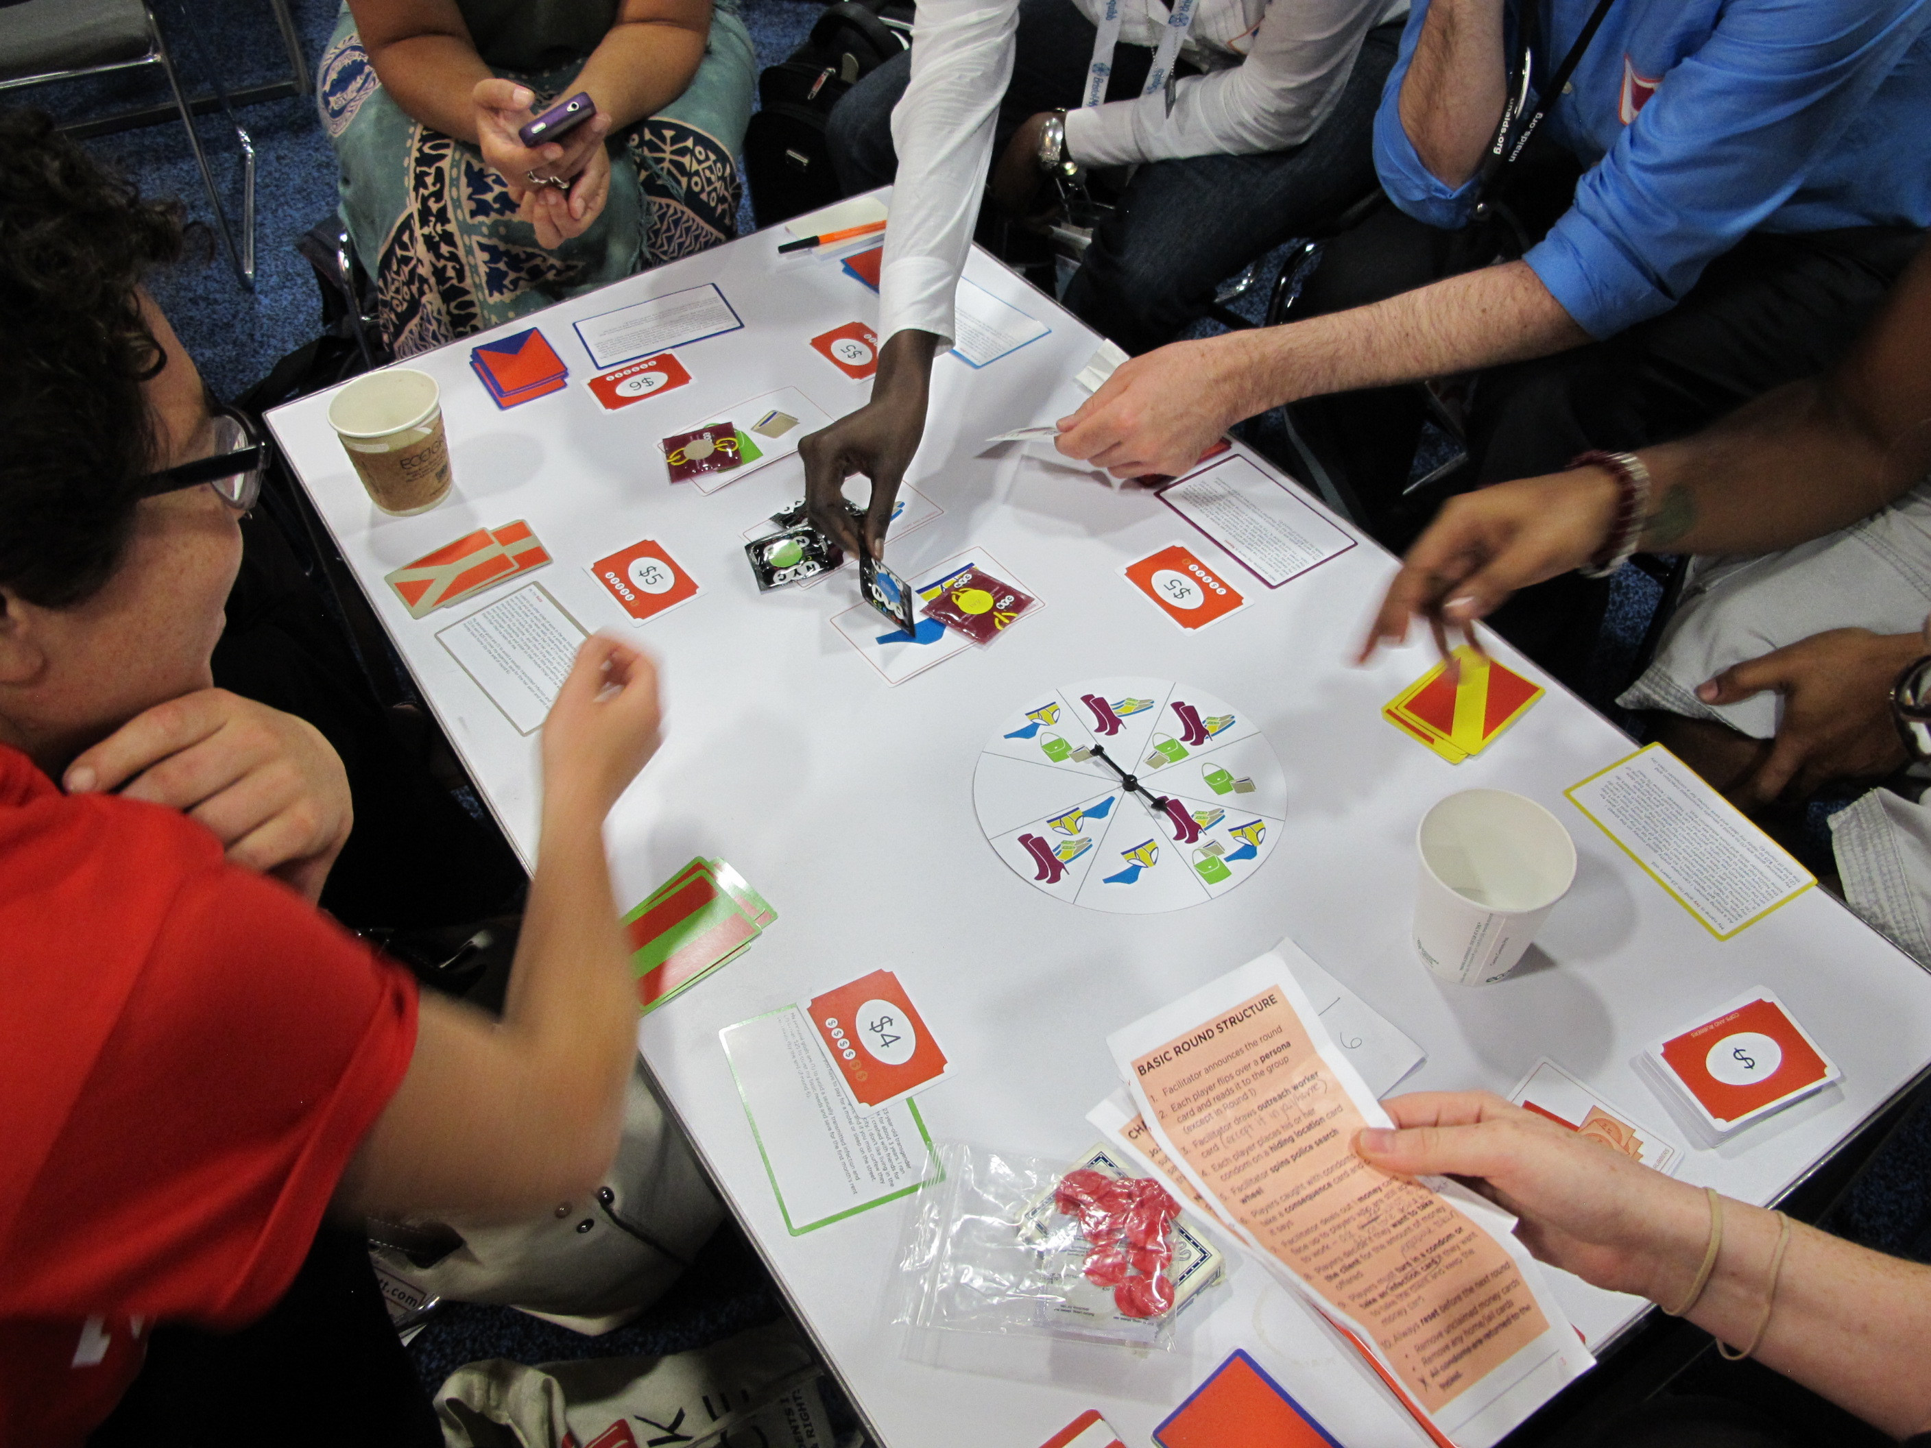

The initial game design started similar to Depression Quest with a digital based interactive game to put players in the shoes of a person with depression. This project helped explore the general theme in The Daily Grind, but for the audience of high school students I had to change the game system to be more physical. Once I decided the game system was something physical, like a board or card game, I began exploring ideas from We’ve Got Issues. I found the major downfall of this system was that it did not educate the players as much as I would have liked, so I made sure my game had more factual based elements on the cards and not just phrases. We’ve Got Issues is a great card based system that is fun to play and is very lighthearted for a topic such as mental illness, but it lacks a strong message once the game is finished. The Daily Grind takes the idea of a “fun” card game, but on a more serious tone.

Cops and Rubbers is a great example of a serious game based on sex workers and how real life government policy has consequences on these workers. This game design is more educational and serious, but still makes players feel like they are just playing a game. This model is similar to how The Daily Grind system works based on real research and actual people’s experiences. This gives both games a level of integrity and makes users get a more impactful experience at the end.

1. **Methodology**
2. ***Concept & Mind Mapping***

Started the design process by exploring topics that would be interesting that I was passionate about. Mental illness and specifically depression has affected friends and myself over the years. So I felt depression awareness “game” could really make a positive impact. After deciding on the concept, I choose the audience of high school students and began mind mapping and rapid prototyping. More notes and images for initial stage can be viewed [here](http://kelseykjeldsen.com/depression-awareness-game-concept-prototyping/).

**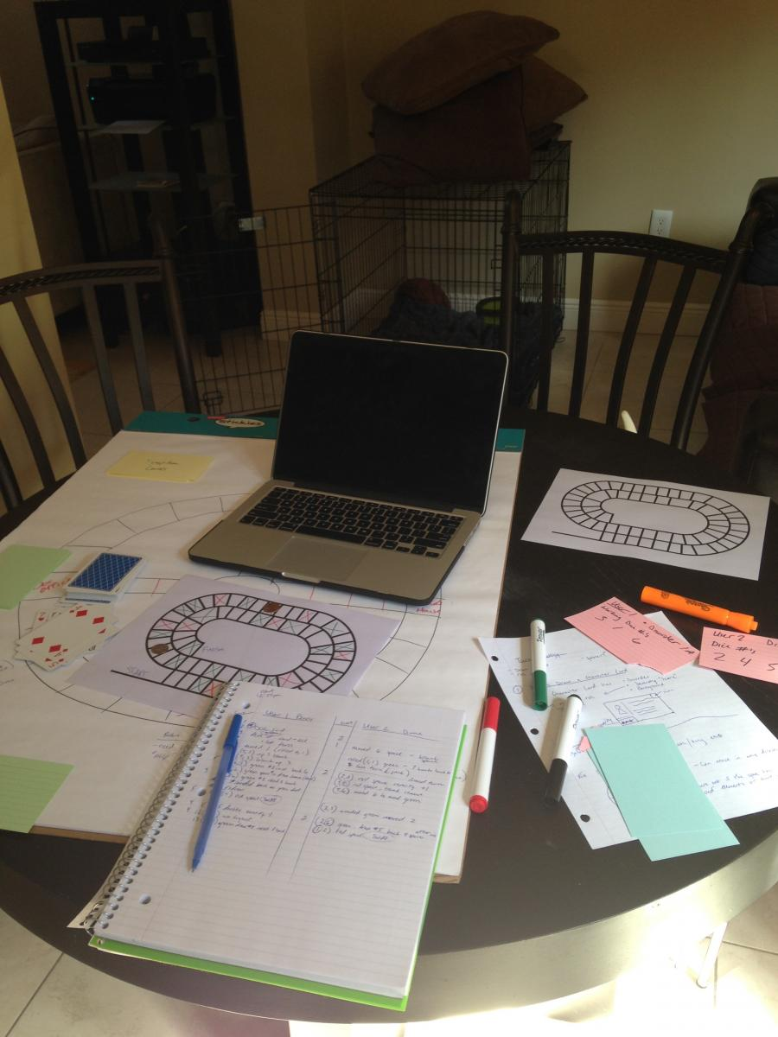**

Figure 1 - Play testing with Game Board and Regular Cards. Recording the result of each move of both players to find probabilities.

**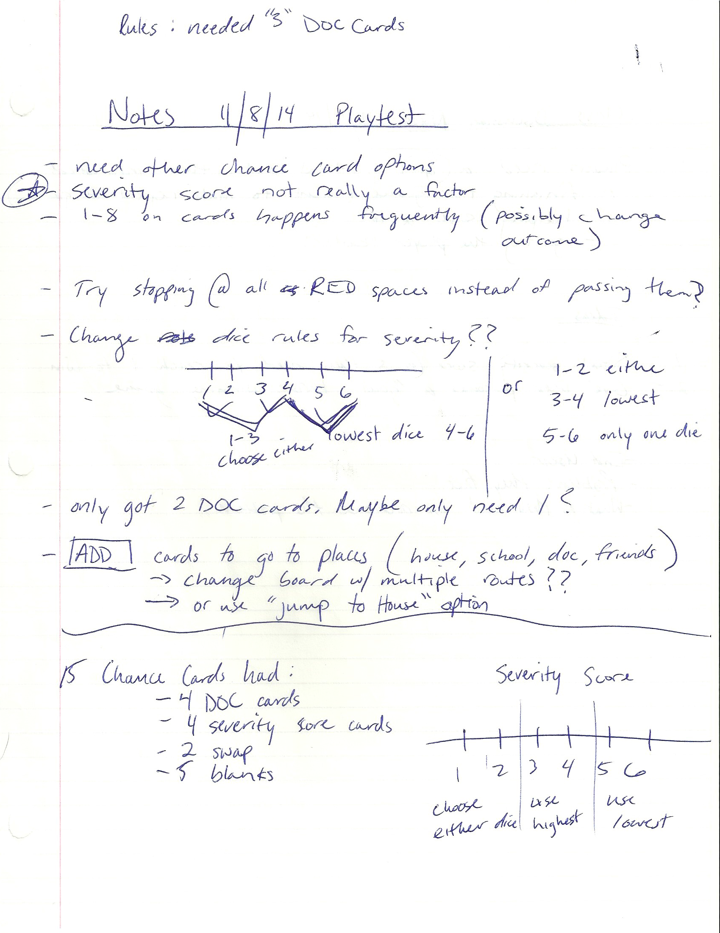**

Figure 2 Play testing Notes for game elements. Game version with board and cards drawn when you land on certain color spots.

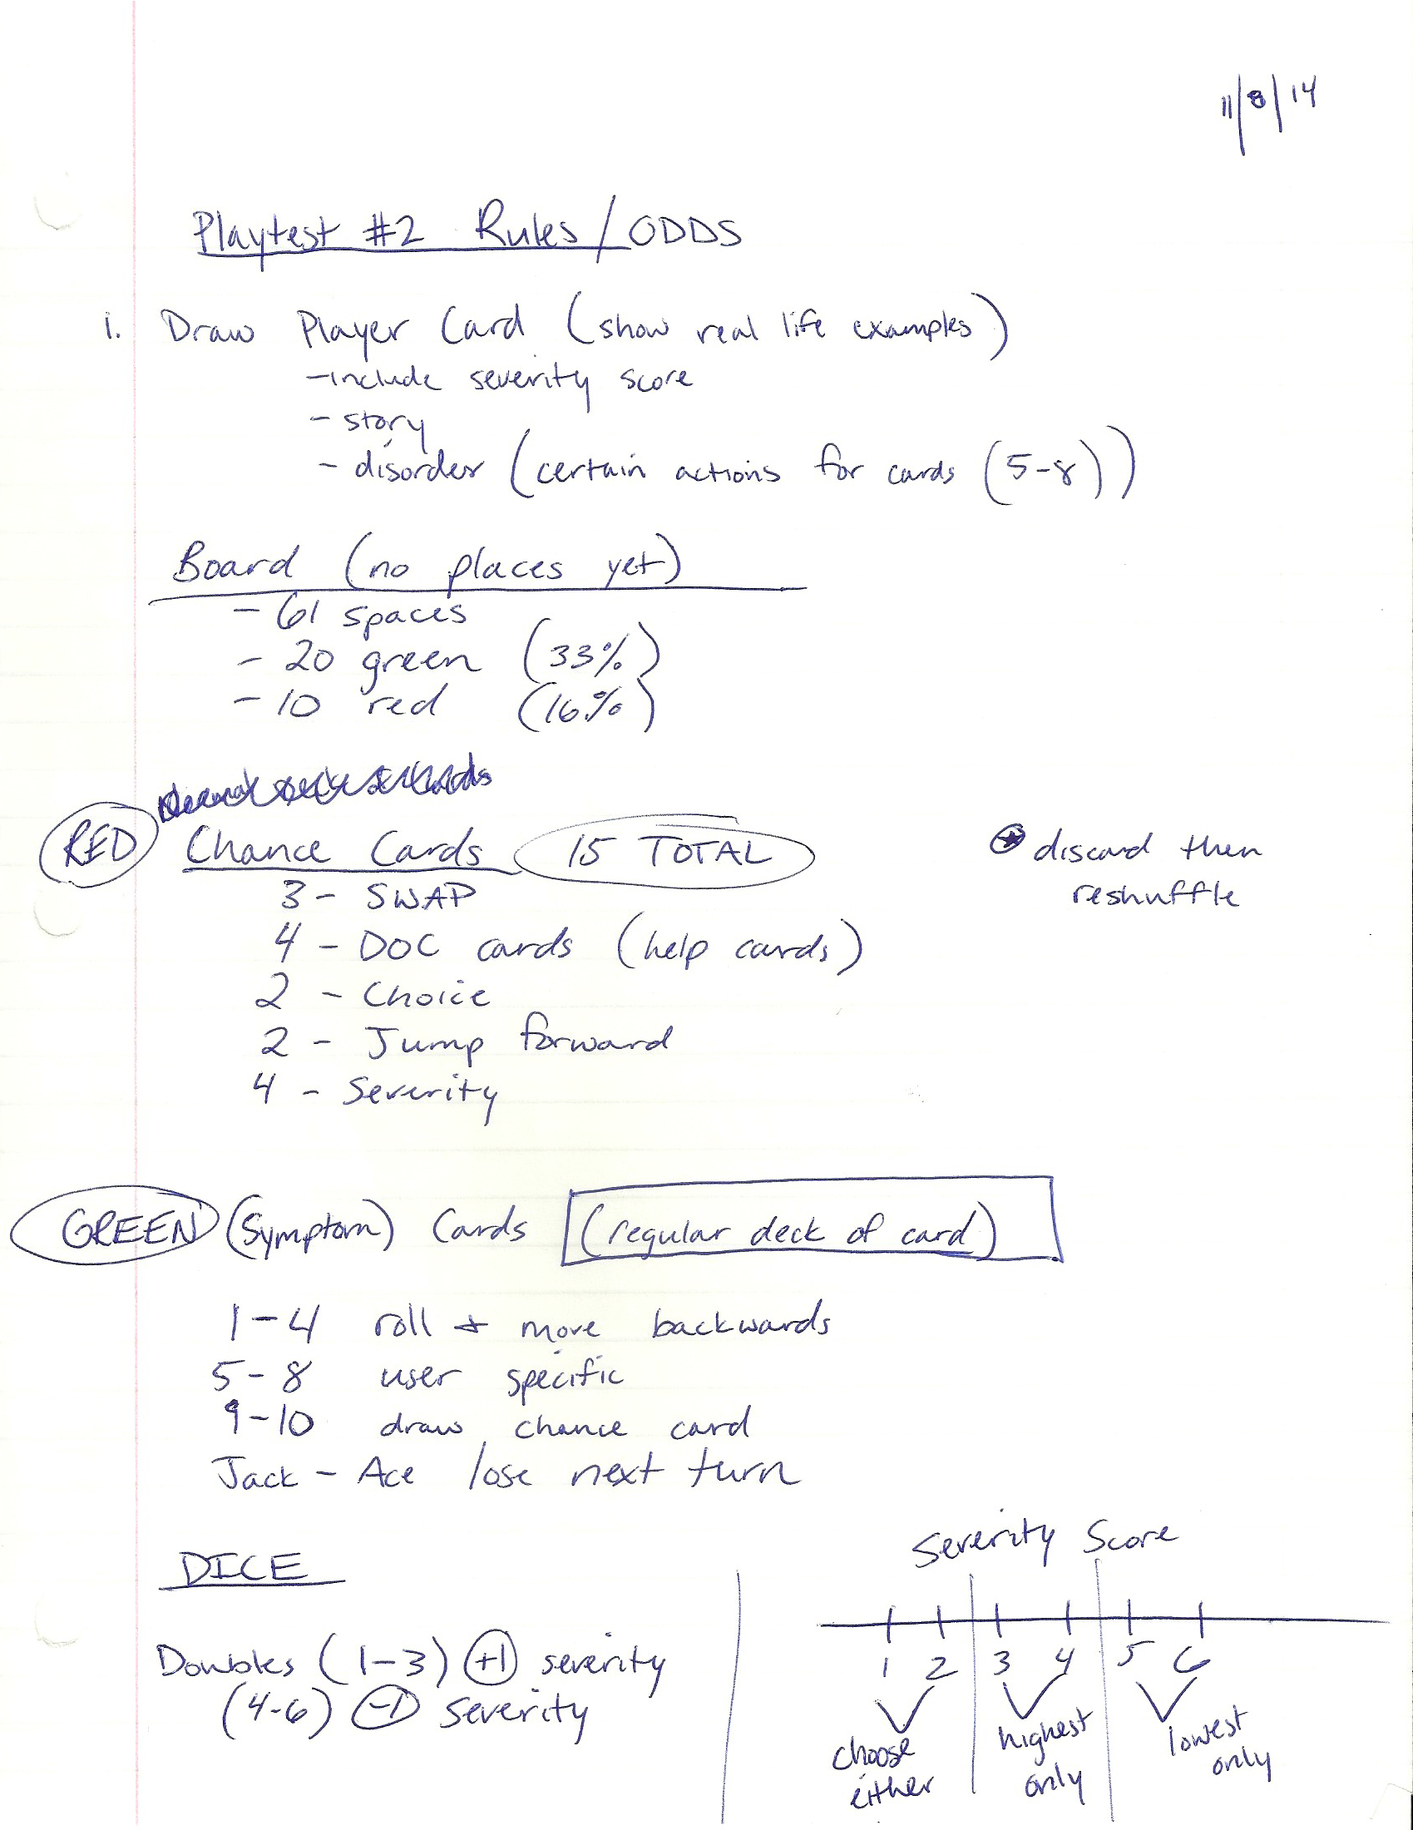

Figure 3 Rules/Odds for Playtest 2 showing the actions players would do on certain dice roles or cards based on the space they landed on the board.

1. ***User Test with Game Cards***

First real user test of “The Daily Grind” included a game board with 62 spaces, dice, a regular deck of cards, severity scale, and two piles of custom cards. The goal of the game was to reach the end of the game board first. The game included depression symptom cards and level of severity scale to simulate what real depression might feel like. The scale goes from “Mild” to “Neutral” to “Severe," severe being the highest level of depression. These elements were what changed throughout the game when a player rolled the die during their turn.

In this version players would land on either a green, red, or blank space on the board and complete the associated action. For example, a green space meant the player draws a symptom card (which was the regular deck of cards) and depending on its value an action would happen. Each value had different actions that either moved your severity score (where you were on severity scale), made you lose a turn, roll again, or had a user specific unique action.

After this test I found that the probabilities of each type of action needed to be altered and that the game board served little to no purpose for the player besides choosing their card pile. I also found that the severity scale was an element of the game worth keeping but it needed to be varied more by player actions for it to become more interesting. During many rounds of this playtest users severity scores were not altered so the game because monotonous.

1. ***Changing System and Probabilities***

After a few user tests with the game board system I decided to change the game to focus on an issue many people who suffer from depression experience which is lack of productivity. Many of the symptoms of depression affect that person’s ability to accomplish day-to-day tasks, so I tried to express this inside the game. This new version of the game was a “deck building” game where players get “Task cards” and want to complete to gain points. In order to complete tasks players would use Action card points (later changed to Activity points) during their turn. To make completing tasks more difficult and realistic to person experiencing depression, there are symptom cards that affect the player’s odds and severity score. Players also have the option of moving their severity scale level by completing “Treatment cards” that can move their score down. Figure 4-6 below shows the design process and note taking for play testing of the deck-building version.

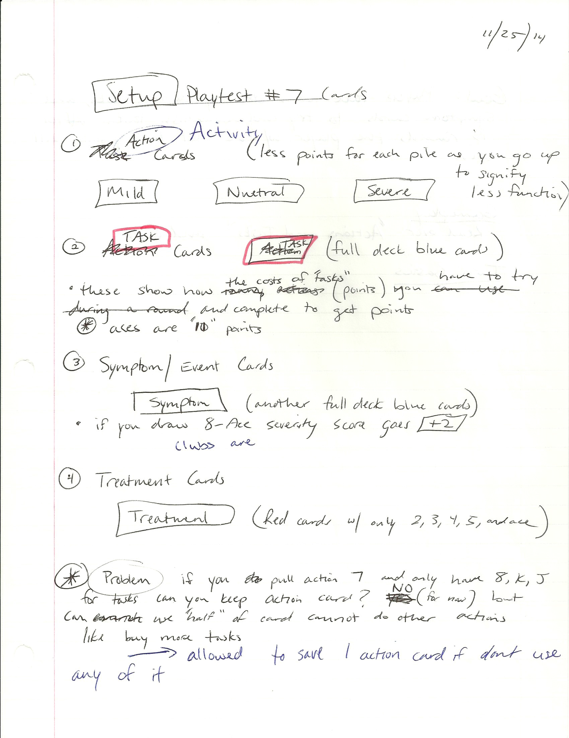

Figure 4 Deck Building Playtest Rules and Setup. This explains the elements of the cards and what actions a player was able to do for this playtest.

**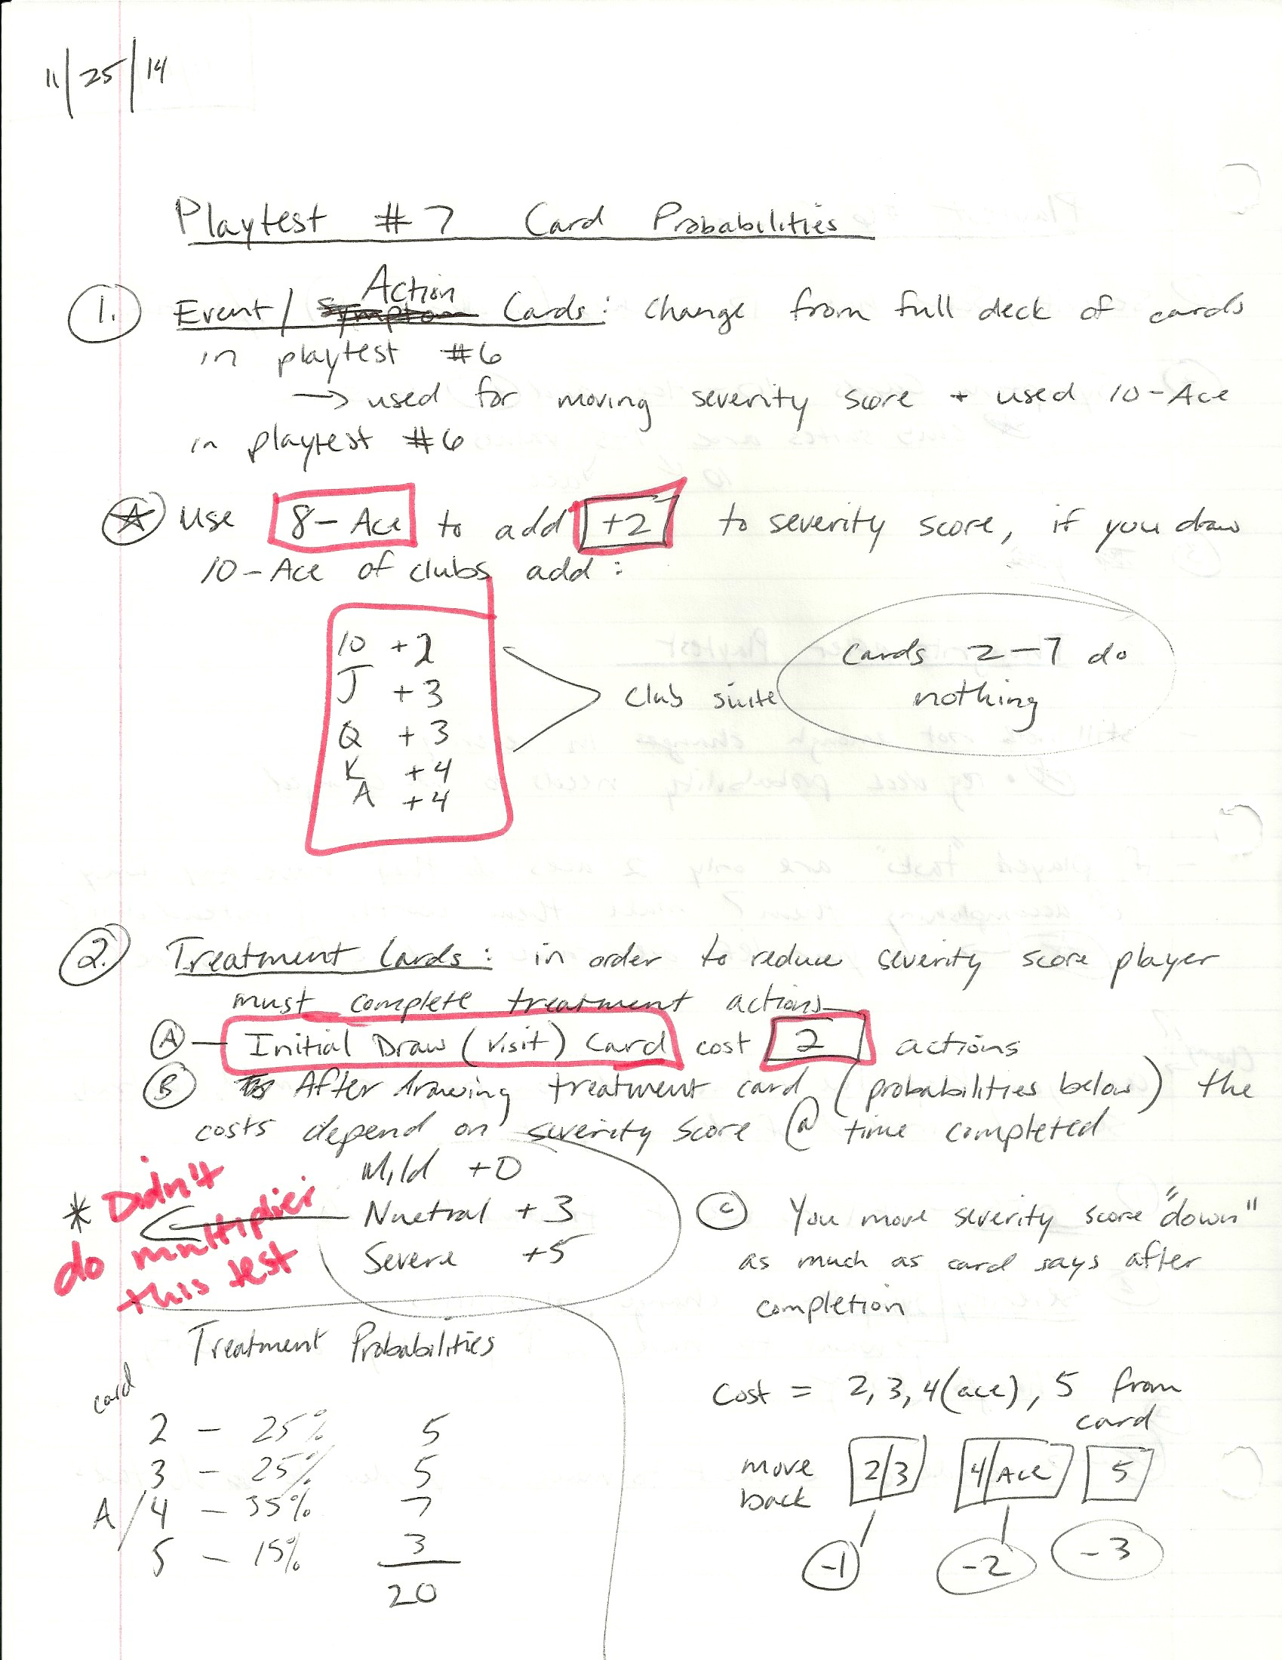**

Figure 5 Probabilities and Card Values for Deck Building Game version 1. These notes described the probabilities of a card or action occurring in this playtest.

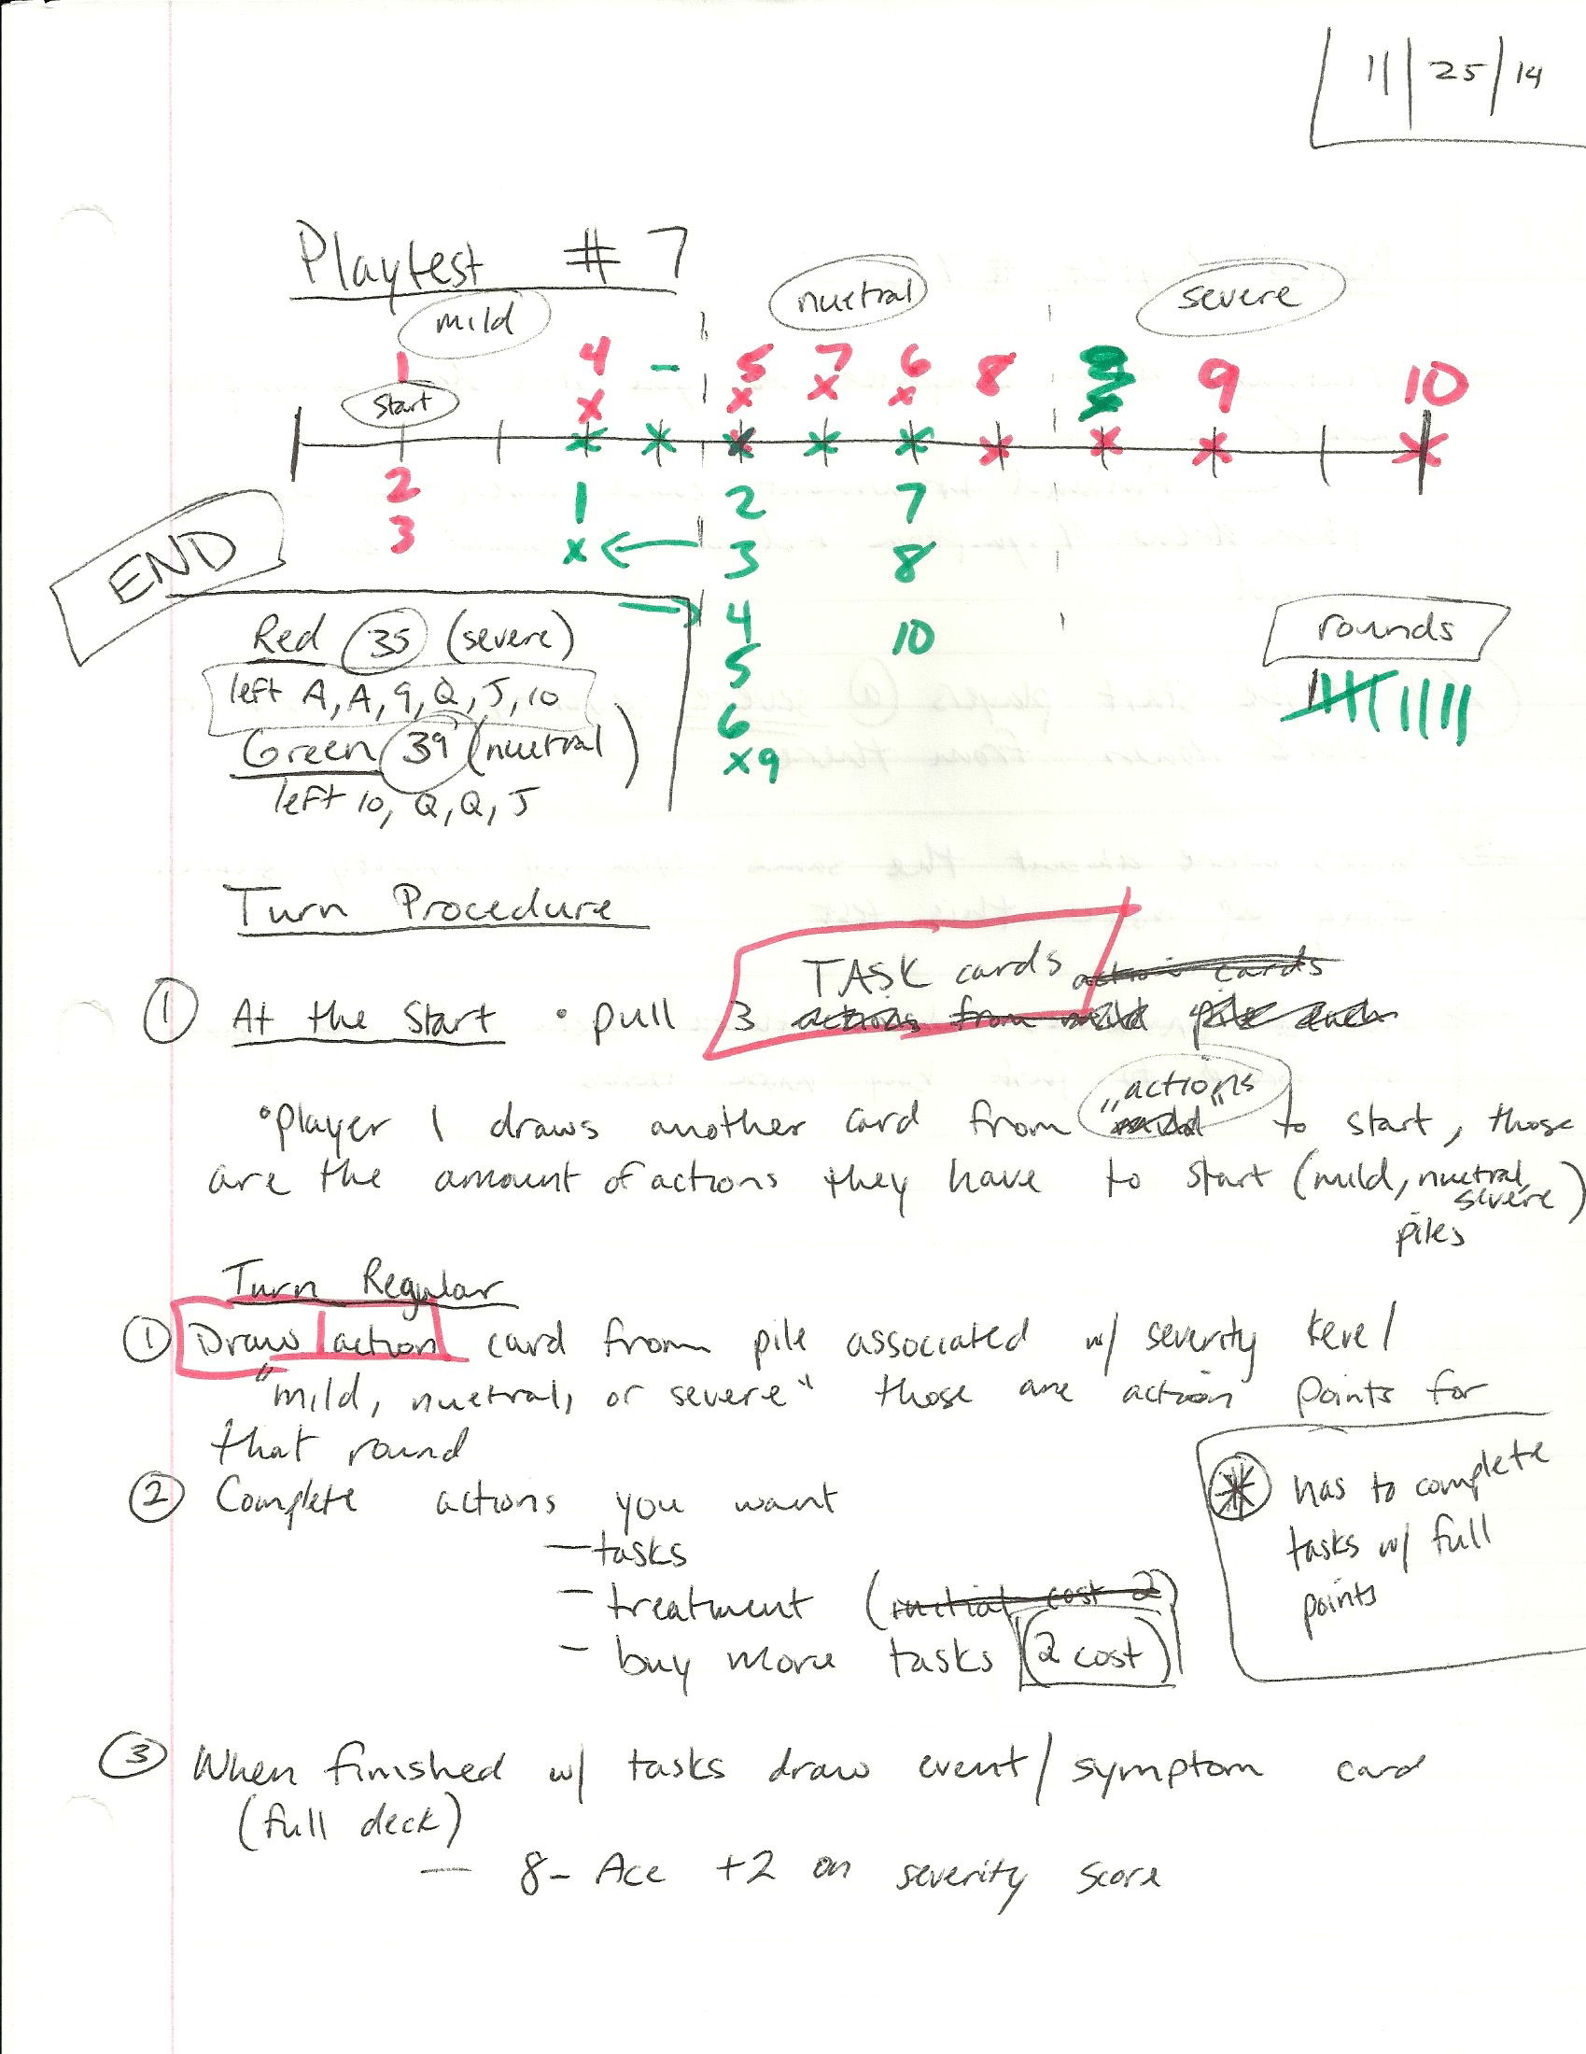

Figure 6 Turn Procedure and Severity Scale for this playtest of the Deck Building Game version.

***3a. Reflections of Deck Building Game Playtest***

This game version was better than the board version but still had some issues with severity score and the probabilities. At certain points during the game it became almost impossible for players to complete tasks, forcing them to only have the option of completing treatments. Completing treatments is an action that I wanted to stress in the game to educate players on the benefits, but I still want players to be able to have a choice in their actions during the game. The game is meant to make players have a difficult time choosing which available actions to do so that it simulates the feelings of someone experiencing depression. Conversely, I also want players to feel at points that they have no control of certain game outcomes because that is also what some people with depression experience.

Despite the issues with probabilities, players were able to understand the game easily but had consistent feedback about the cards. Players felt that by using mostly regular standard deck of cards they did not get the full experience of depression awareness and education. Although this playtest was purely for the game system, players needed actual designed cards that showed text about symptoms and player actions. 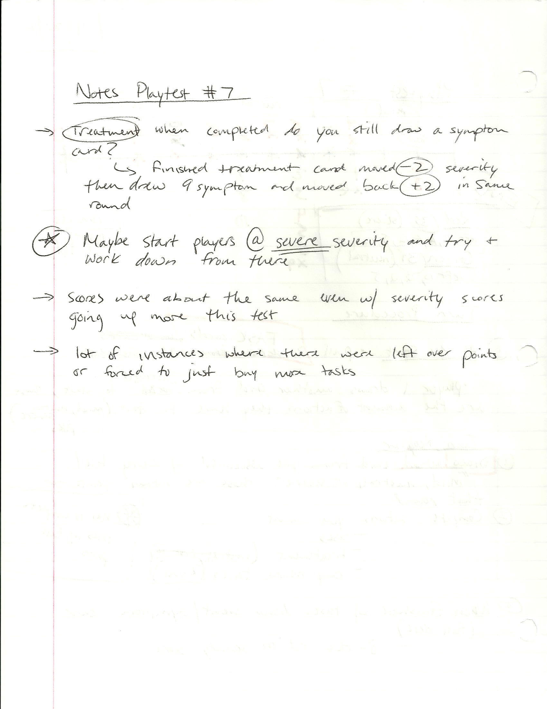

Figure 7 Notes after Playtest of Deck Building Game with player reactions and possible changes for the system.

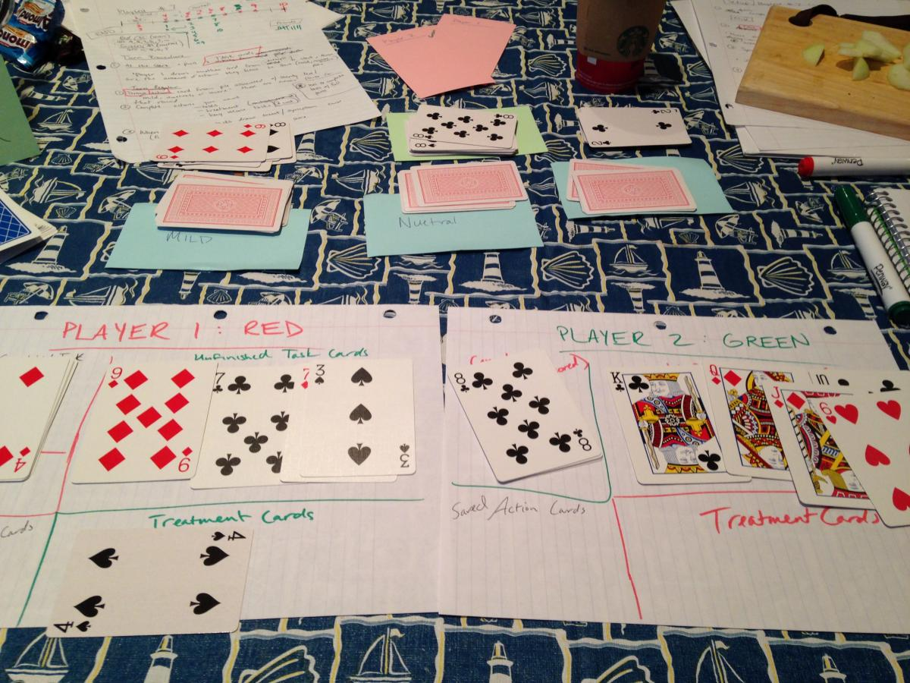

Figure 8 Playtest with Deck Building Game showing card piles for mild, neutral, and severe. Players have cards for tasks and completed tasks.

1. ***Final Designed Cards Prototype***

In order to test user reactions without standard card decks I created actual unique cards that included text about depression and its symptoms and treatments. My main focus in creating cards was to include relevant text for the game while also giving valuable information about depression that was thought provoking. Figures 9 shows all the different card type designs, and more can be seen on [here](http://kelseykjeldsen.com/depression-game-daily-grind-pt-2/). The final promotional video can also be seen on my [blog](http://kelseykjeldsen.com/daily-grind-promo-video/).

Figure 9 Card Types from top left: Activity cards, Chance Activity card, Task Card, Chance Treatment, Treatment Card, and Symptom Card

*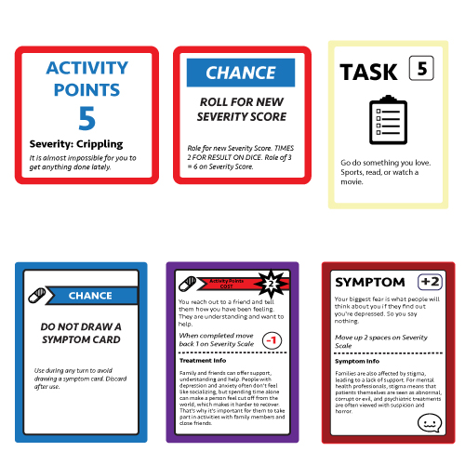****4a. Reflections of Final Playtest***

After implementing designed cards user’s reactions were much better to the game. They were able to feel empathy afterwards about mental illness and reacted more positively about the choices in the game. There was still a lack of choice during the playtest and some users expressed that during their turn it felt “routine” and got boring towards the end. If this game was meant to be a purely social game then I would take into account the level of “fun” later, but since the main focus is a classroom activity I am less concerned with the “fun” element for now. I want to make sure that students will learn more about depression and have a stronger sense of what people who suffer from it may go through on a daily basis. This game version seems to accomplish that goal and reduce the stigma that users had about mental illness before playing this game.

1. **Evaluation**

Overall “The Daily Grind” game came out well with some improvements to be made in the future. In terms of the look and feel of game elements like cards and game sheets they could be more professional. The cards serve the purpose that they need to but could be produced with more high quality and laminated so that players get the feel of an actual game card. In terms of the game system it needs more player choice and interactivity to make the game “repeatable.” This prototype works as an educational tool right now but players would be hard-pressed to play the game a second time. Possibly inserting elements of physical game play or mini games could improve the interactivity and make users more willing to play again.

With more time and iterations this prototype could be have been improved. The beginning of my design process focused heavily on the system and card probabilities, which took longer than expected. Ideally I would not have gone to designing any unique cards until my game system was finalized and “fun” but with a deadline the cards needed to be produced. Designing unique cards did improve the game but made it more time consuming and difficult to make changes to the system after I received feedback from users.

1. **Next Steps**

For the future of The Daily Grind I would like to finalize the system and improve elements of player choice, possibly including mini games. After more user tests of the improved system I will put together a debrief for teachers to use once the game is finished being played. This will help facilitate a conversation about mental health after the game and make it easier for teachers to use in the classroom. Once the materials and system are finalized, I will put the game up on [thegamecrafter.com](http://www.thegamecrafter.com) for final production. This will help make the game more professional and keep all the materials standardized. If the card game version of the game is adopted positively then I will explore creating a digital version, which automates the game moves and makes the game faster.

1. National Alliance for Mental Illness. “Depression: Gaps & Guideposts

   Summary of Findings” 11 November 2014. <http://www.nami.org/Content/NavigationMenu/Mental_Illnesses/Depression/Depression_Gaps_and_Guideposts_Summary_of_Findings.htm> [↑](#footnote-ref-1)
2. World Health Organization. “Depression a Hidden Burden” 14 November 2014. <http://www.who.int/mental_health/management/depression/flyer_depression_2012.pdf?ua=1> [↑](#footnote-ref-2)
3. National Alliance for Mental Illness. “Depression: Gaps & Guideposts

   Summary of Findings” 11 November 2014. <http://www.nami.org/Content/NavigationMenu/Mental_Illnesses/Depression/Depression_Gaps_and_Guideposts_Summary_of_Findings.htm> [↑](#footnote-ref-3)
4. National Institute of Mental Health. “Depression in Children and Adolescents (Fact Sheet).” 26 November 2014. <http://www.nimh.nih.gov/health/publications/depression-in-children-and-adolescents/index.shtml> [↑](#footnote-ref-4)